FlightController User Manual

Contents
No table of contents entries found.

Important Features
The FlightController add-on by Sikorsky Control has a few important features that should be learned and memorized prior to operating the add-on.

FlightController Add-On
- Lightweight, effective and eye-catching PCB design
- Takes advantage of the integrated LiPo (Lithium Polymer) battery
- Multicolored LED lighting to indicate height

Safety Instructions
- Attention! This controller is not a toy. It is a complex prototype that can cause personal injury and property damage when handled improperly. It is solely the user’s responsibility to ensure its safe operation!
- This manual must be read and understood in its entirety prior to operating the add-on!
- The add-on is suitable for use indoors as well as outdoors when there is no wind.
- The add-on is suitable for engineering students who are at least 17 years of age. Engineer supervision is required when using it.
- Keep your hands, face, eyes, nose, hair, limbs, extremities and other body parts away from any part of the add-on, moving or stationary, at all times.
- Always switch off the add-on when it is not in use.
- Remove the add-on from the helicopter when it is not in use.
- Always maintain visual contact with the add-on to ensure that it does not get lost.
- As soon as the add-on no longer functions reliably, stop using it.
- Please keep this user manual safe for later use. Do not expose it to water, fire, sharp blades, direct sunlight, or other objects or elements that can damage the user manual or otherwise render it unreadable.
- The user should only operate the add-on in accordance with the instructions for use in this user manual.
- Do not use the add-on near people, animals, plants, bodies of water, open fire, lava, magma, corrosive acid, ceilings, walls, floors, furniture or power lines.
- Never allow the add-on to come into contact with water, fire, lava, magma or acid. This may result in its electronics becoming damage.
- Always watch the aircraft to ensure it does not fly into and injure other people or animals.
- Before use, it must be ensured that the add-on cannot injure anyone in consideration of potential malfunction and defects.
- Do not use the add-on for any other purpose than to operate the Revell Sky Fun RC Helicopter. Do not attach the add-on to other model helicopters, or an actual helicopter.
- Do not modify the add-on in any way. This may lead to it becoming damaged to posing a threat to national security.
- Do not operate the add-on while sitting on the ground or in a chair in order to minimize damages caused by impeded response time. Operate the add-on from a position from which you can easily evade a dangerous aircraft.
- The add-on is not suitable for people with physical or mental disabilities, and people who do not have an advanced understanding of electronics.
- People who are unfamiliar with model helicopters, electronics, PID controllers and C++ software may only operate the add-on under supervision of an experienced embedded systems engineer.

Maintenance and Care
- Do not use water to clean the add-on. Only use a dry rag to wipe off any dust buildup.
- Store the add-on in a cold, dark environment, preferably a vacuum.

For instructions on how to properly utilize and care for the Revell Sky Fun RC Helicopter, read the user manual enclosed with it.

Using the GUIgor
The GUIgor (Graphical User Interface Igor) is a piece of software used to set several variables in the add-on, and to simulate the included PID-controller.
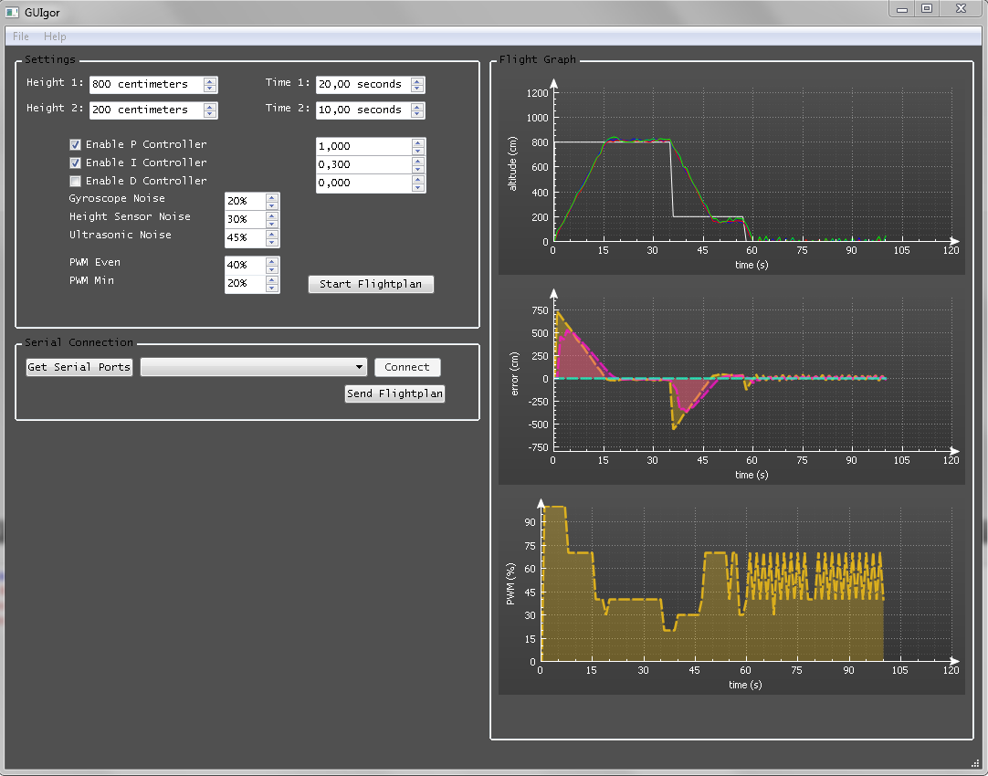

Adjusting and uploading a flight plan
- Change ‘Height 1’ to the desired first height, in centimeters.
- Change ‘Time 1’to the desired time you want the helicopter to stay at the first height, in seconds.
- Repeat steps 1 and 2 for the second height.
- Connect the add-on to your computer via the UART, and power on the add-on.
- Click the ‘Get Serial Ports’ button.
- Select the serial COM Port the add-on is connected to in the adjacent drop-down menu.
- Click the ‘Connect’ button.
- Click the ‘Send Flightplan’ button.

Simulating the PID controller
- To enable or disable the Proportional, Integral and Differential controllers, check or uncheck the ‘Enable P Controller’, ‘Enable I Controller’ and ‘Enable D Controller’ checkboxes respectively.
- Set the Proportional, Integral and Differential factors by clicking the arrows next to the numeric up/down counters adjacent to the appropriate controller.
- Change the amount of simulated noise for each of the three sensors by clicking the arrows next to the numeric up/down counters
- Set the PWM percentage at which the helicopter is stable in the numeric up/down counter labelled ‘PWM Even’.
- Set the minimum allowed PWM percentage during flight in the numeric up/down counter labelled ‘PWM Min.
- Click the ‘Start Flightplan’ Button.
The three graphs to the right show the simulated flight plan.
- The first graph shows the set heights (white line) and the three sensors; the heightsensor (blue line), the gyroscope (red line), and the ultrasonic sensor (green line).
- The second graph shows the results from the Proportional (yellow line), Integral (purple line) and Differential (light blue line) controllers.
- The third graph shows the resulting PWM output to the engines of the rotors of the helicopter.

Using the add-on
Once the proper flight plan has been flashed onto the add-on, simply turn on the add-on and wait for the LED indicator to flash green. The add-on will then ensure that the helicopter will fly its designated path. If the LED indicator does not flash green, there is a problem (see Chapter 5 Troubleshooting).

Troubleshooting
Problem | Cause | Solution
The LED does not turn on when the add-on is powered up. | - The Lithium Polymer battery has been depleted | - Charge the Lithium Polymer Battery
The LED flashes red. | - There is a problem with the height sensor.  - There is a problem with the gyroscope.  - There is a problem with the ultrasonic sensor. | - Have an experienced engineer connect to the USART of the add-on and check the error code.
The helicopter does not lift off of the ground. | - The Lithium Polymer battery has been depleted too much.  - The helicopter is broken. | - Charge the Lithium Polymer battery.  - Replace the helicopter.

